**// STRING BASED TASK – 6 //**

Q1. Java Program to Add Characters to a String

Input:

Input custom string = Hello

// SOURCE CODE

import java.util.Scanner;

public class AddString {

public static void main(String[] args) {

Scanner sc = new Scanner(System.in);

String mainStr, addStr;

int position;

System.out.print("Enter the main string: ");

mainStr = sc.nextLine();

System.out.print("Enter the string to add: ");

addStr = sc.nextLine();

System.out.print("Enter the position (0 for beginning, -1 for end, or index number): ");

position = sc.nextInt();

if (position == -1) {

mainStr = mainStr + addStr;

} else if (position == 0) {

mainStr = addStr + mainStr;

} else if (position >= 0 && position <= mainStr.length()) {

mainStr = mainStr.substring(0, position) + addStr + mainStr.substring(position);

} else {

System.out.println("Invalid position");

return;

}

System.out.println("Output String: " + mainStr);

}

}

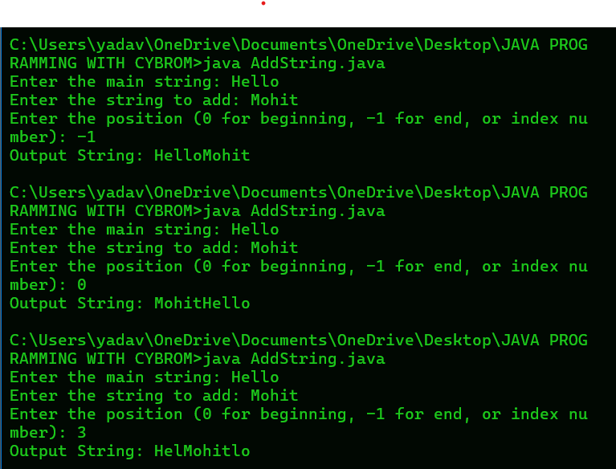

Q2. Java Program to Iterate Over Characters in

String?

// SOURCE CODE

import java.util.Scanner;

public class IterateStringCharacters {

public static void main(String[] args) {

Scanner sc = new Scanner(System.in);

System.out.print("Enter a string: ");

String str = sc.nextLine();

for (int i = 0; i < str.length(); i++) {

System.out.print(str.charAt(i));

if (i < str.length() - 1) {

System.out.print(" ");

}

}

}

}

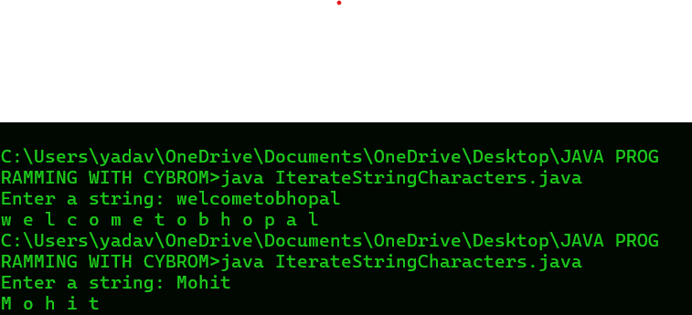

Q3. Java Program to get a character from a

String?

Examples:

Input: str = &quot;hello&quot;, index = 3

Output: l

Input: str = &quot;welcoME to bhopal&quot;, index = 6

Output: E

// SOURCE CODE

import java.util.Scanner;

public class GetCharacterFromString {

public static void main(String[] args) {

Scanner sc = new Scanner(System.in);

System.out.print("Enter the string: ");

String str = sc.nextLine();

System.out.print("Enter the index: ");

int index = sc.nextInt();

if (index >= 0 && index < str.length()) {

char result = str.charAt(index);

System.out.println("Character at index " + index + ": " + result);

} else {

System.out.println("Invalid index! Please enter an index between 0 and " + (str.length() - 1));

}

}

}

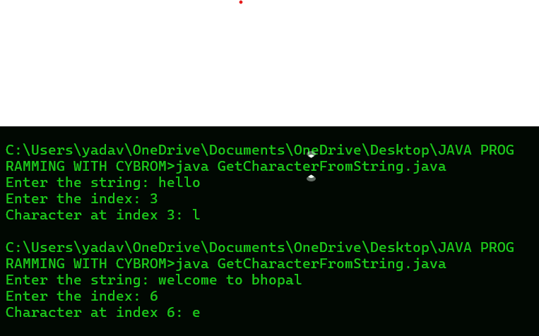

Q4. Java Program to Convert String to String Array?

// SOURCE CODE

import java.util.Scanner;

public class StringToArray {

public static void main(String[] args) {

Scanner sc = new Scanner(System.in);

System.out.print("Enter the string: ");

String str = sc.nextLine();

// Split the string into an array based on spaces

String[] strArray = str.split(" ");

System.out.println("String Array Elements:");

for (String word : strArray) {

System.out.print(word + “ “);

}

}

}

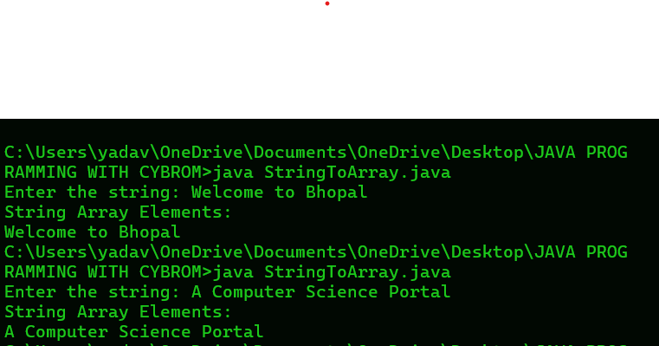

Q5. Swapping Pairs of Characters in a String in Java?

Input: str = “Java”

Output: aJav

Explanation: The given string contains even number of characters. Therefore,

we swap every pair of characters.

// SOURCE CODE

import java.util.Scanner;

public class SwapCharacterPairs {

public static void main(String[] args) {

Scanner sc = new Scanner(System.in);

System.out.print("Enter the string: ");

String str = sc.nextLine();

StringBuilder swappedStr = new StringBuilder(str);

for (int i = 0; i < str.length() - 1; i += 2) {

char first = str.charAt(i);

char second = str.charAt(i + 1);

swappedStr.setCharAt(i, second);

swappedStr.setCharAt(i + 1, first);

}

System.out.println("Swapped String: " + swappedStr.toString());

}

}

